Class 10A First term project Math
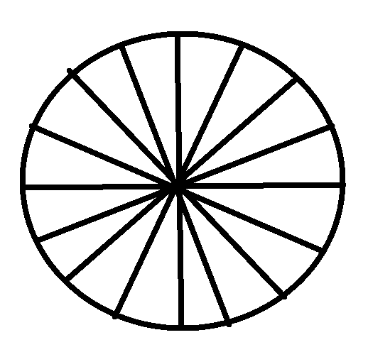
Last Date of submission Wednesday 12 August 2020
1. Prove that Area of circle is equal to π r²
Pre require knowledge i) Area of triangle ii) circumference of circle
Procedure:
Procedure: Construct 3 circles of radius multiple of 7. E.g. 7, 8.4, 9.1, 7.7, 6.3 ….
Construct a circle on a chart paper and divide it in to triangle by joining lines from the center of the circle.
Find the area of triangle by using formula
Adding area of all triangles provide the area of circle.
½ r (l₁ + l₂ + ….) = ½ r x c = ½ r x 2 π r
Detail working discussed in class.
2.Procedure: Construct 3 circles of radius multiple of 7. E.g. 7, 8.4, 9.1, 7.7, 6.3 ….
Take arc about 1cm and cut through circumference.
Join the end of arc to the centre of the circle and cut it out.
Arrange the pieces to form a rectangle whose breadth is equal to the radius of the circle.
Measure the length of rectangle. Find the area of rectangle = l X b
Verify with the formula of area of circle.

2. Data Handling
Collect the mathematics marks of your class, prepare frequency distribution table taking class interval of 0 - 10,10 – 20 so on.
Draw the histogram with the following information, find the mode from histogram.
Also plot in an ogive graph, median marks and calculate the number of students getting more than 60% of marks and those getting less than 40% of marks.
Calculate Mean marks of the class by any one method.

