Proposed Projects for History and Civics [HCGI] FIRST TERM 2019-2020
Last Date of Completion : 15th July 2019
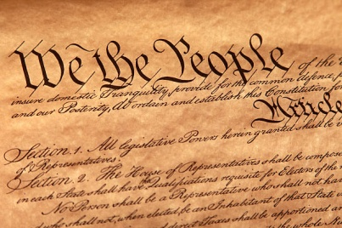
Class 6 : Topic- The election 2019-picture analysis to explain Features.
Use half of chart Paper to execute picture analysis.

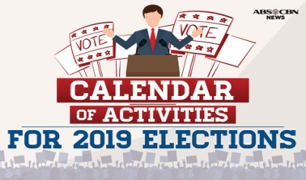
Class 7 : Topic:Election 2019:an analytical expression of Making of
The prime Minister of India.
Poster making. In half of the Chart paper.

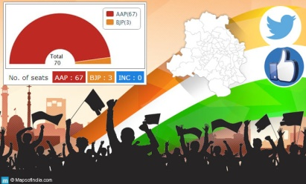
Class 8: Topic- Election 2019; the way legislature is made; an analysis
In a handmade Booklet.

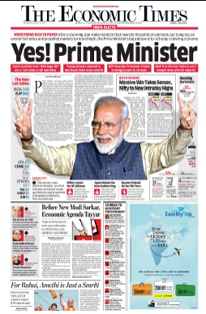
Class 9: Topic- Election 2019- The agenda and it’s relation with the features
of the Constitution.

In a handmade folder

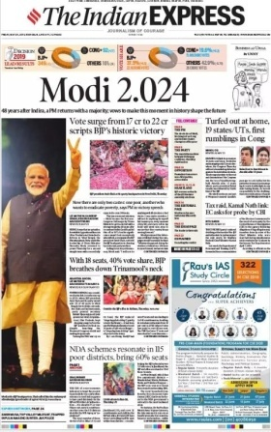

Class 10: Topic- Election 2019-Powers and functions as bestowed.
Critical Analysis In form of Chart.

NOTE: All Projects are Class Projects of the above mentioned Classes and will have 5
marks Aural.

