Height and Distances: For class 10A Mathematics
Make your own instrument to measure height of objects:
Take a protector, stick a hollow pipe on the straight surfaces as shown in the diagram. Punch a hole with sharp needle at 90 mark and hang some load with string.
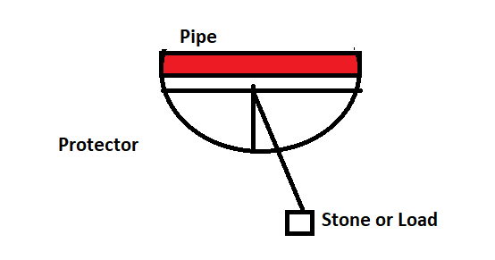
When you look at any object through the pipe, the string measure the angle of elevation from the protector.
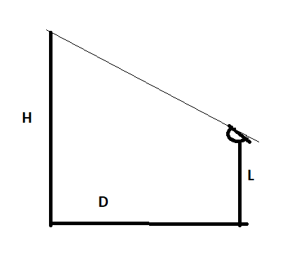
As shown in the diagram point the top of the object whose height to be measured. Find the angle, find tan Q from trigonometric table. Measure the distance D from the foot of the object. Measure L the height of stand from which observation is made.
$$\tan{∅=\frac{H}{D}}$$
Find H from the equation.
Actual height of the object = H + L

You can measure height of wall, tree, building also height of a person.
Measure height of three things with help of your instrument.

