Proposed Projects for History and Civics [HCGI] ANNUAL EVALUATION 2019-2020
Last Date of Completion : 15th January 2020
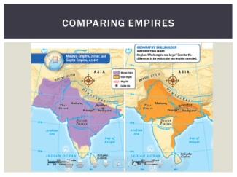
Class 6 : Topic- Administration of Ashoka, Samudragupta and Chandragupta II.
Use half of chart Paper to present in Chart form.
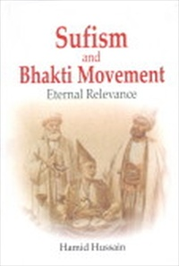
Class 7 : Topic:Impact of bhaktism and Sufism- Analysis
In a booklet.

Class 8: Topic- UNO : an analysis based on Principles,its Organs,Agencies-Composition and
Functions.
In form of Wall Hanger. Must follow order.

Class 10: Topic- An Interview with 5 Personalities:Raja Rammohan Ray,Balgangadhar Tilak
Netaji Subhash Chandra Bose,Benito Mussolini and Adolf Hitler.
On file paper, Fact based.

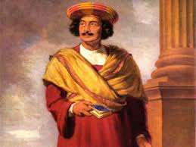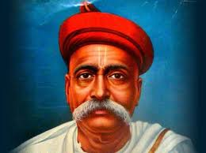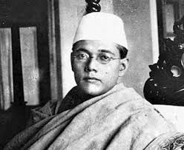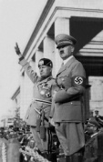

NOTE: All Projects are Class Projects of the above mentioned Classes and will have 5
marks Aural.

