**NOTICE**

**ATAL TINKERING LAB**

This is to notify that The BGES School (ICSE) is going to set up ATL at 12C Heysham Road.

The lab will be operated in interest to nourish and culture innovative ideas of students. The laboratory will be equipped with tools and machineries which can be used for craft work, carpentry, building robots, artificial intelligence, electronics, 3D printing technologies, assembling drone and innovate and tinker with any issues arises from day to day life.

Students of classes 5 to 10 irrespective of their streams are requested to propose their name as **“I AM THE INNOVATOR ATL THE BGES SCHOOL”** to class prefects by 30 July 2019.

Children of Teachers’ and Staffs who are not students of The BGES School may also propose their name to DS.

Please note that the ATL will be functional during and beyond school hours as decided by school.

For any further information’s please contact: Debmalya Sen (Teacher, The BGES School)

By order

Headmaster

Dated : 1 July 2019

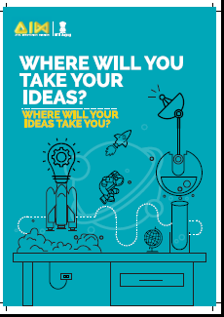

**I AM THE INNOVATOR ATL THE BGES SCHOOL**

|  |  |  |  |  |
| --- | --- | --- | --- | --- |
| Reg No | NAME | CLASS / SEC | Experience in robotics. ( Y/N) | Remarks |
|  |  |  |  |  |
|  |  |  |  |  |
|  |  |  |  |  |
|  |  |  |  |  |
|  |  |  |  |  |
|  |  |  |  |  |
|  |  |  |  |  |
|  |  |  |  |  |
|  |  |  |  |  |
|  |  |  |  |  |
|  |  |  |  |  |
|  |  |  |  |  |
|  |  |  |  |  |
|  |  |  |  |  |
|  |  |  |  |  |
|  |  |  |  |  |
|  |  |  |  |  |
|  |  |  |  |  |
|  |  |  |  |  |
|  |  |  |  |  |
|  |  |  |  |  |
|  |  |  |  |  |
|  |  |  |  |  |
|  |  |  |  |  |
|  |  |  |  |  |
|  |  |  |  |  |
|  |  |  |  |  |
|  |  |  |  |  |
|  |  |  |  |  |

To be used by Class prefect