COLLECTION OF MARKSHEET ICSE MARCH 2020

Schedule for collecting ICSE Marksheet March 2020 is as given under

Class Roll No Day Date Timmings
10A 1 to 10 Monday 27 Jul 1000h to 1030h
10A 11 to 20 Monday 27 Jul 1030h t0 1100h
10A 21 to 30 Monday 27 Jul 1100h to 1130h
10A 31 Onwards Monday 27 Jul 1130h to 1200h
10B 1 to 10 Tuesday 28 Jul 1000h to 1030h
10B 11 to 20 Tuesday 28 Jul 1030h to 1100h
10B 21 to 30 Tuesday 28 Jul 1100h to 1130h
10B 31 Onwards Tuesday 29 Jul 1130h to 1200h

ENTRY TO THE SCHOOL WILL BE FROM 23A, JUSTICE CHANDRA MADHAB ROAD (NORTHERN PARK SIDE)

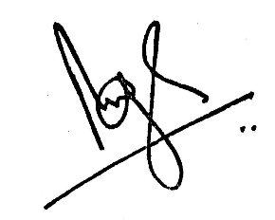
Brij Bhushan Singh
Headmaster
22 Jul 20

