MATHEMATICS PROJECT
CLASS: 10B
TOPIC: ANGLES IN THE SAME SEGMENT OF A CIRCLE ARE EQUAL
OBJECTIVE: To verify that the angle in the same segment of a circle are equal using the method of cutting, pasting and folding.
MATERIALS REQUIRED:
- Geometry box
- Practical workbook
- Coloured chart papers – yellow, blue and red
- Scissors
- Scale
- Sketch pen
- Adhesives or glue sticks
- Tracing papers – 2
PROCEDURE:
- Draw a circle of 5 cm radius on a blue coloured chart paper. Use black sketch pen for drawing.
- Cut out the circle.
- Take a yellow chart paper. Cut it in the size of an A4 sheet and paste the circle on it.
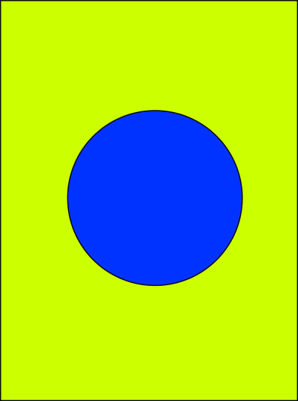
- Fold the circle in any way such that a chord is made. Draw the line segment AB.
- Take two points P and Q on the circle in the same segment.
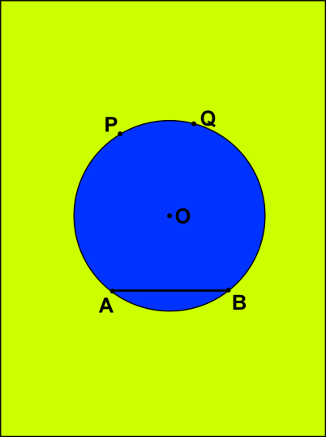
- Form a crease joining AP. Draw AP.
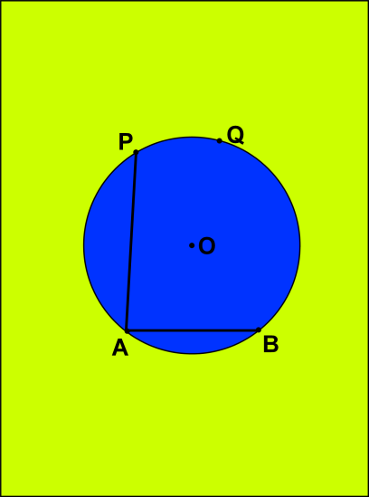
- Form a crease joining BP. Draw BP.
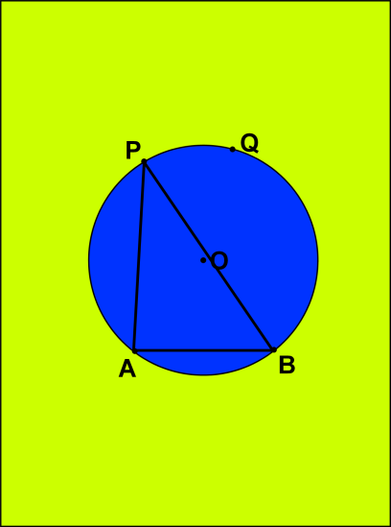
- $∠APB$ is formed in the major segment.
- Form a crease joining AQ Draw AQ.
- Form a crease joining BQ. Draw BQ.
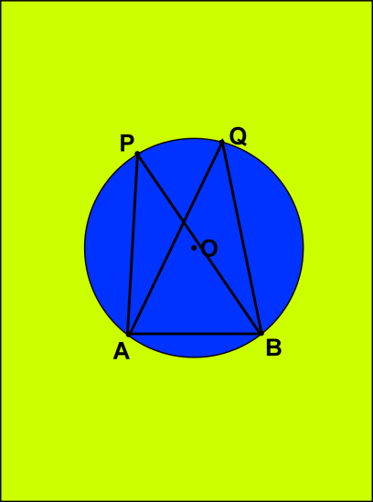
- $∠AQB$ is formed in the major segment.
- Place tracing paper on the circle and draw a replica of the $∠APB$ and $∠AQB$. Prepare two such replicas of $∠APB$ with green or red chart papers.
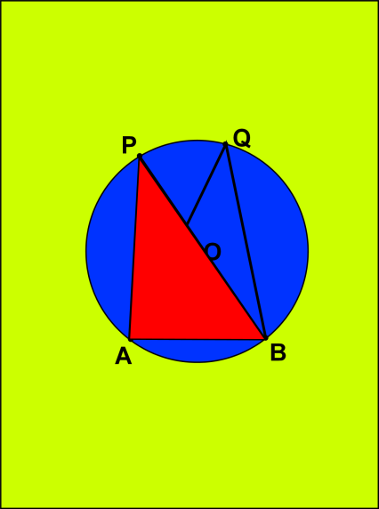
- Place the cutout of $∠APB$ on $∠AQB$. Stick the other replica along the edge BQ.

RESULT:
It is noted that $∠APB$ = $∠AQB$ and these angles are in the same segment. $∠APB$ is completely covered with $∠AQB$ and thus the theorem is verified.
LAST DATE OF SUBMISSION OF PROJECT: 15TH SEP 2020

TOPIC: (i) SUM OF EITHER PAIR OF OPPOSITE ANGLES OF A CYCLIC QUADRILATERAL IS 180^{O} (ii) IN A CYCLIC QUADRILATERAL THE EXTERIOR ANGLE IS EQUAL TO THE INTERIOR OPPOSITE ANGLE
OBJECTIVE: To verify that the (i) sum of either pair of opposite angles of a cyclic quadrilateral is 180º (ii) in a cyclic quadrilateral the exterior angle is equal to the interior opposite angle materials required
MATERIALS REQUIRED:
- Geometry box
- Practical workbook
- Coloured chart papers – yellow, blue and pink
- Scissors
- Scale
- Sketch pen
- Adhesives or glue sticks
- Tracing papers – 2
PROCEDURE:
- Draw a circle of 5 cm radius on a blue coloured chart paper. Use black sketch pen for drawing.
- Cut out the circle.
- Take a yellow chart paper. Cut it in the size of an A4 sheet and paste the circle on it.
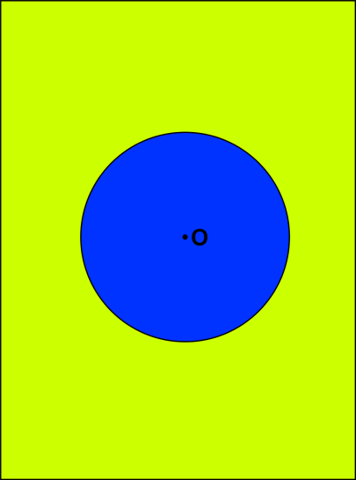
- By paper folding get the chords AB, BC, CD and DA.
- Draw the line segments AB, BC, CD and DA. Cyclic quadrilateral ABCD is obtained.
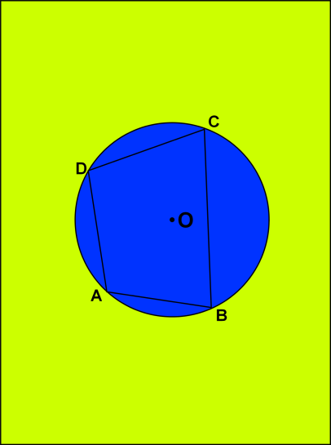
- Make a replica of cyclic quadrilateral ABCD using a tracing paper. Now draw the quadrilateral on the pink chart paper with the help of tracing paper and cut it out.
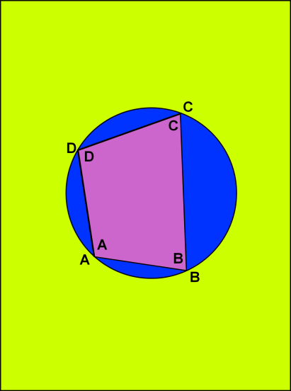
- Now cut the quadrilateral in 4 parts such that each part contain one angle like $∠A, ∠B, ∠C, ∠D$.
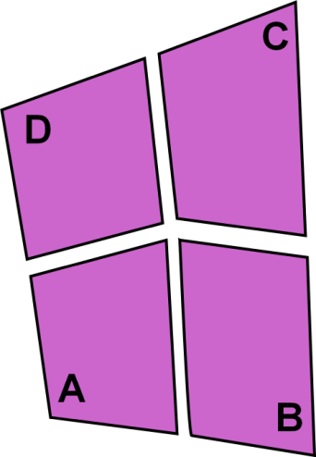
- Place $∠A$ and $∠C$ adjacent to each other.
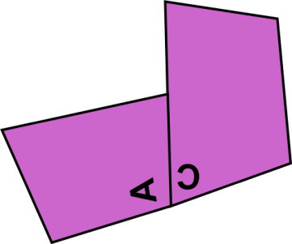
- Produce AB to form a ray AE. Exterior $∠CBE$ is formed.
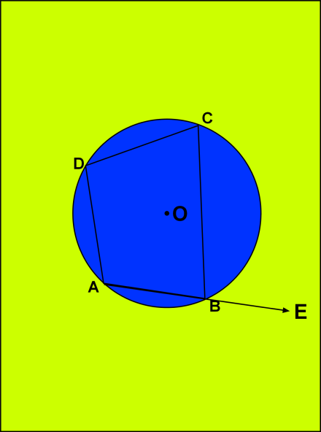
- Place the replica of D on $∠CBE$.
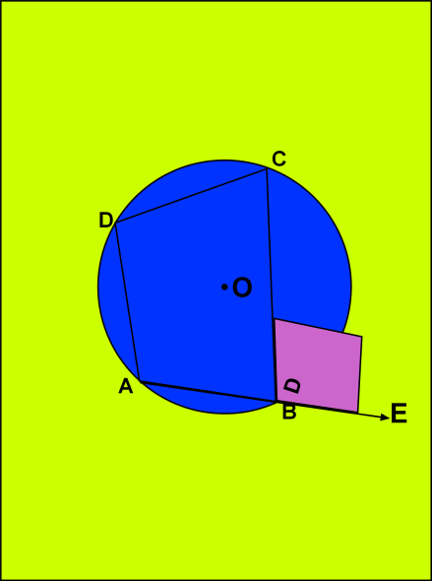
RESULT:
It is noted that when $∠A$and $∠C$ are placed adjacent to each other they form a linear pair:$∠A$ + $∠C$ = 180º. Also, $∠D$ completely covers $∠CBE$. This shows that the exterior angle of a cyclic quadrilateral ABCD is equal to the opposite interior angle.
LAST DATE OF SUBMISSION OF PROJECT: 15th SEP 2020

