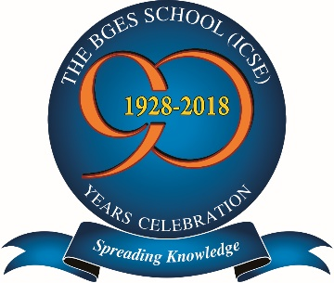
The BGES School (ICSE)
12B Heysham Road
Kolkata 700020

07 Feb 22

Date Second Dose Covaxin for students above the age of 15 Years

The school will organise Second Dose Covaxin for students above the age of 15 Years on Wednesday 16 Feb 2022 at 1045h in the Walia Hall 3 LLR Sarani. Kolkata 700020.

Class 10A Science students will join up after they finish their Physics Preliminary Examination.

Class Teachers of 9&10 to please be present and organise the vaccination process.

Procedure as given in notice dated 05 Feb 22 will be followed.

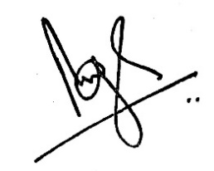
Brij Bhushan Singh
Principal

