Notice for the students studying in class 8,Academic Year 2021-22
OPTION FOR SCIENCE OR COMMERCE
Applications from the students of class 8 (2021-22) to opt for science or commercial studies groups of subjects for the ICSE Exam is to be made by all students.
Last date of application is 15th Jan 2022.
The steps for application is explained below:
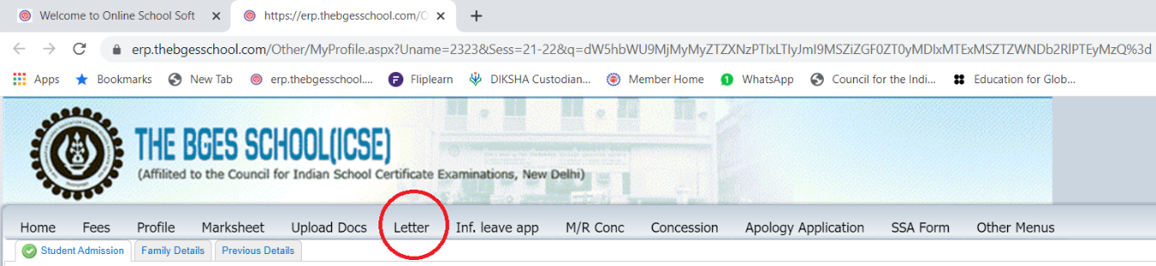
Students should login to school soft with their respective ID and password, select the tab “Letter” .
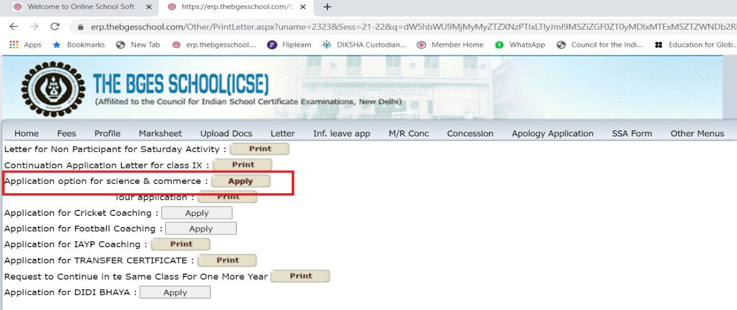
On selecting “Letter”, the option for application for stream selection will appear.
On clicking “Apply” you can select your option of stream and then click on “SEND” tab to complete the procedure of application.
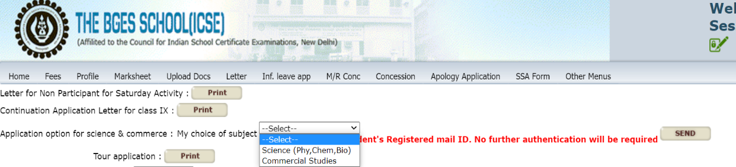

In case of any discrepancy please preserve copy of application made to Registered mail ID of student.
Since the mail will be generated from individual portfolio no further authentication will be required and selection sent will be full and final. No changes will be allowed later.
Allotment Procedure of Science Subject to Class 9 Study carefully before filling the form
In the month of Feb every year the process of allotment of Science Subject to Class 9 will be started. This will be provisional till the results of Annual Examination are declared. The allotment would be based on student/guardian choice and the first term marks as also due diligence at the school.
Science subjects will be allotted conditionally as stated below:-
Group 1. Allotted science with condition that if they secure below 45% (inclusive) in the annual examination of class 8 in Mar, they will be asked to opt for CST.
Group 2. Allotted science with condition that they have to secure above 45%(inclusive) in the external assessment (out of 80 marks paper) and have an average of 55% combined internal (out of 20 marks for projects) and external assessment (out of 80 marks paper) at the annual examination of class 8 in Mar.
Only then they will be allotted science. Till then they will stand allotted CST. A final list will be put up along with the results of the Annual Examination.

In case there is no response from the parent or the student it will be presumed that their option is CST and same will be allotted.

Principal
The BGES School (ICSE)
15 Dec 21

