Proposed Projects for History and Civics [HCGI] ANNUAL EVALUATION 2020-2021
Last Date of Completion : 15th July 2020
Based on the recent past and as an observer of historical pandemic phase 2020
CLASS 9
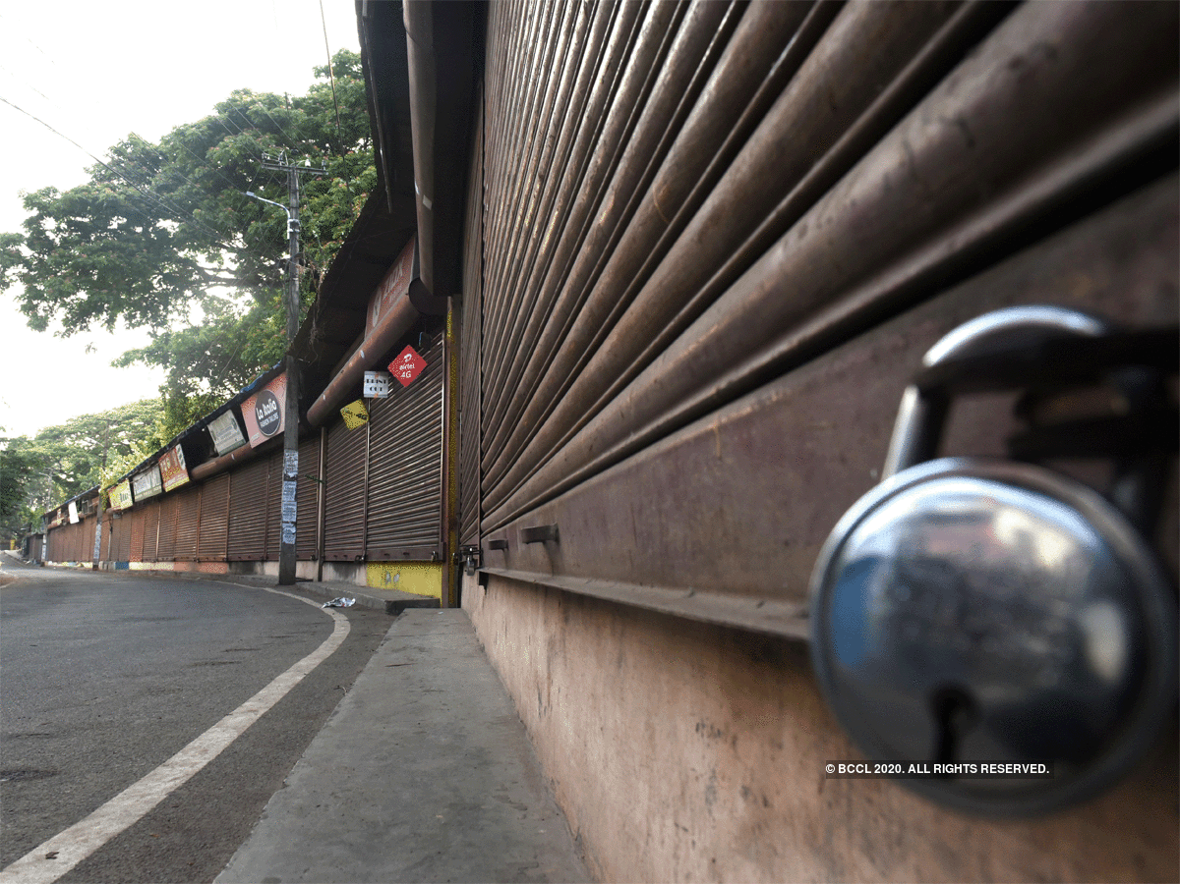
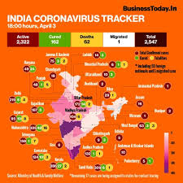
CLASS 10
ONLOOKERS OF HISTORY, YEAR 2020
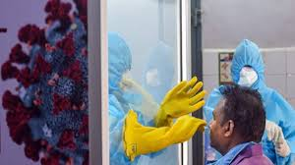
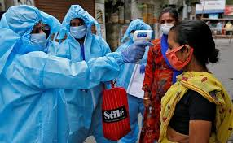
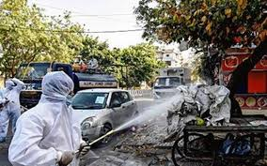
A Report writing with significant information and analysis of the changes it might bring in the society globally in health, economic and social sectors. It has to be done word document or 4 to 5, A4 sized pages or 6/7 pages of your Notebooks. Put some suitable pictures.

NOTE: All projects have to be done, by the provisions available at HOME and submission by dated, as scheduled in the school Calendar, Session 2020-2021. You can mail @ baishalid1@gmail.com

