Practical Work Class 10
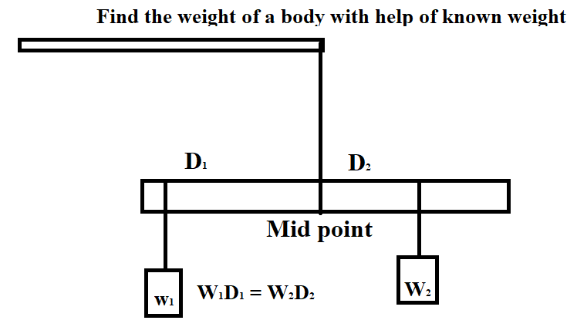
1. Find the mass of unknown body with help of known mass using principal of moment of force.
For further detail see experiment on lever (Practical note book).

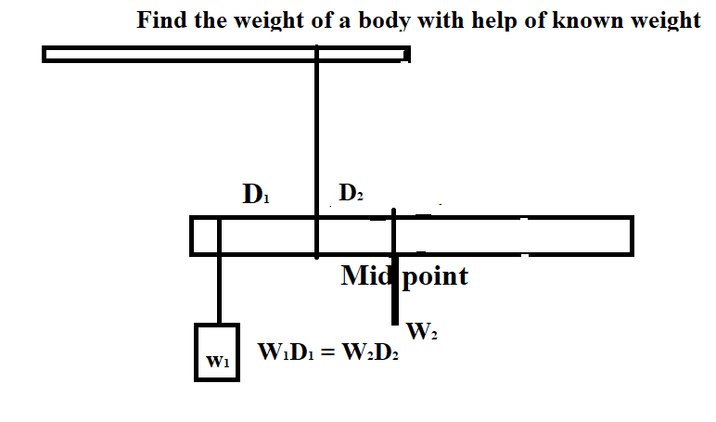

2. Find the mass of scale using principal of moment of force,

3. Find “g” by help of pendulum made by you.
Steps:
- Find the time period (T) of pendulum for 3 different lengths (L).
- Find the ‘g’ by using formula g = 4π² L / T²
- Find the average of ‘g’.

Please mail your Class work and home work along with Practical work soft copy in PDF or image file naming with( your name, class and page number, topic) to ‘ 1debmalyasen@gmail.com’
Last date of submission 22 Aug 2020.

