MATHEMATICS PROJECT
CLASS: 9B
TOPIC: PYTHAGORAS THEOREM
STATEMENT: In a right angled triangle, the square of the hypotenuse is equal to the sum of the squares of other two sides.
OBJECTIVE: To verify the above theorem through activity.
PRE-ACQUIRED KNOWLEDGE: Definition of a square and triangle formula for the area of square.
MATERIAL REQUIRED:
- Drawing sheet/ coloured chart paper
- Geometry box
- Pair of scissors
- Fevistick/gum
PROCEDURE:
- Draw any right angled triangle ABC, right angled at C on a coloured chart paper. Let the lengths of AB, BC and CA be 4 cm, 3 cm and 5 cm respectively.
- Construct squares on AB, BC and CA. Let the colours of the squares be yellow, green and blue.
- Make 10 exact replicas of $∆$ABC (Red)
- Take 4 replicas of $∆$ABC along with the one replica each of green and blue squares all on a sheet as shown in figure 2.
- Take the remaining 4 replicas of $∆$ABC (red) and one replica of yellow square and paste on one sheet as shown in the figure 3.
RESULT:
- We observe that each of the figure as shown in figure 2 and figure 3 is a square of side (a + b) units.
- Therefore, area of the square in figure 2 = area of square in figure 3
- Now 4 replicas of $∆$ABC is removed from both fig 2 and fig 3.
- Hence, remaining areas of both figures are equal.
- Hence, area of green square + area of blue square = area of yellow square
- Hence, a² + b² = c². Hence proved.

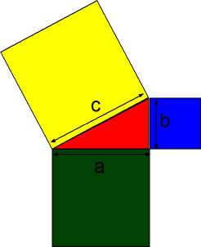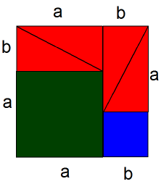
Figure 1 figure 2
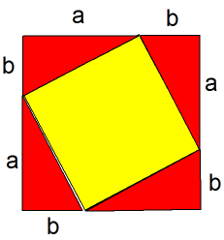
Figure 3

