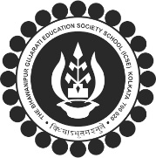
The BGES School (ICSE)
12B Heysham Road
Kolkata 700020

RESULT OF INTER HOUSE FANCY DRESS COMPETITION 2021-22
CLASSES 1-4

Held on 28th Aug 2021
The House Results of the Competition is as follows –

HOUSE | POINTS | HOUSE POSITIONS
GANDHI HOUSE | 66 | WINNER TEAM
PATEL HOUSE | 65 | 1ST RUNNER UP TEAM
NEHRU HOUSE | 62 | 2ND RUNNER UP TEAM
TAGORE HOUSE | 62

BEST DRESS AND SPEECH | POSITION | RG. NO | PARTICIPANTS | CLASS | HOUSE
 | 1st | 2781 | AARADHYA SAKARIYA | 4A | PATEL
 | 2nd | 2954 | HANNAN VORA | 4B | PATEL
 | 3rd | 2943 | PARSHV GANDHI | 3A | NEHRU
 | 3rd | 3439 | KAVYA SHAH | 3B | TAGORE

