Measuring refractive index
If an object is placed at the bottom of a vessel with some transparent liquid and it is seen from the top, the object seems to be lifted up. The ratio of the real depth to the apparent depth from the surface gives the refractive index. You will use this phenomena to get the refractive index.
- Set up 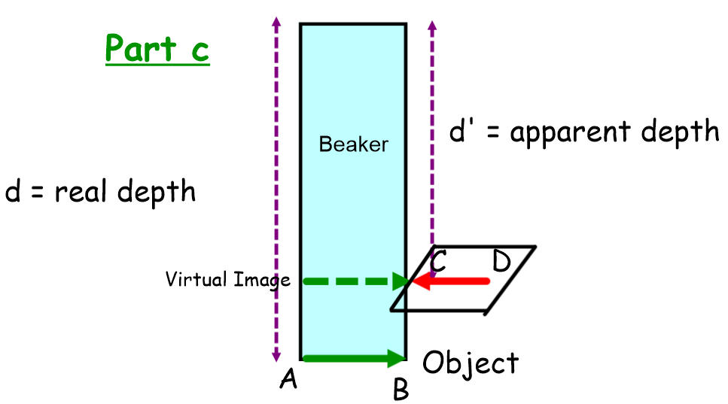
You need a transparent vessel with a thin flat bottom. You may use a suitable plastic box (height at least 10-12 cm) used to store kitchen materials. If you have a beaker of that size that will be fine. You need some cardboards (say 4 cm x 4 cm or larger but of small thickness less than or of the order of a millimetre) or some other material to have an arrangement whose height can be adjusted.
Take a piece of paper and draw a dark straight-line AB on it (so that it remains comfortably visible from above the liquid). Place your vessel on this paper so that the line is visible from the top. Make a similar dark line CD on a cardboard or a piece of chart paper or any other slightly stiff object. Keep the height raising arrangement ready.
- Removing Parallax
Put the cardboard with line CD outside the vessel but touching it in such a manner that AB and CD are in the same straight line.
Pour the liquid in the vessel to some height. Look from the above. If you place your eye in appropriate position, you will still see AB and CD in the same straight line. But if you shift the eye perpendicular to AB, the two lines will be separated.
Adjust the height of CD so that AB and CD seem to be in the same straight line even if the head is moved through large distances in the direction perpendicular to these lines, the lines remain together. You have now successfully removed the parallax between the two lines. The image of AB is formed at the height of CD.
- Link: A video to guide and assist you in removing the Parallax for part C of the experiment has been prepared. The You tube link for it is https://youtu.be/Ng4sQNCi2iI

