12 Mar 19
Dear Parents,
It has been noticed for quite some time that students are not bringing the required Art material for Art/SUPW.
This action is not only detrimental to the child himself but to his class too because the child is not involved in any useful activity and becomes a disturbing element for the balance of class.
In view of the above it is proposed that as and when the student does not get art material for the class, he/she will be issued a new basic art kit .The kit will belong to the student once issued.
The parents will have to deposit Rs. 300 (Rupees Three hundred) to the bank per kit every time it is issued which will cover the cost of the kit plus a nominal fine.
This will come into effect from 01 Apr 19.
Thanking for your cooperation

Your sincerely

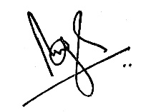
Brij Bhushan Singh
Headmaster

