The Bhawnipur Gujarati Society School
5 LalalLajpat Rai Sarani
Kolkata 700020

NOTICE: SECONDARY SATURDAY ACTIVITY CLUB CHOICE, FOR CLASSES 4 TO 9 (2021-2022)

THIS FORM IS TO BE SUBMITTED BY 23 MAR.2022

Link for the choice of club is as follows:-

https://forms.gle/Vey8QYt3LcR4Axjq6

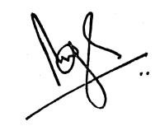
BrijBhushan Singh
Principal

