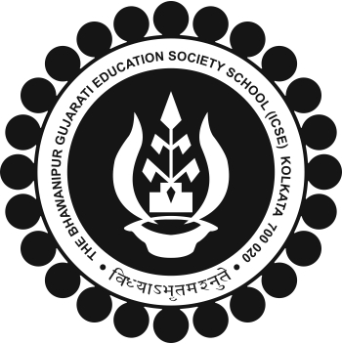
The BGES School (ICSE)
12B Heysham Road
Kolkata 700020

SELF COMPETING AWARDS 2018-19

The Self Competing Awards for the Academic Year 2018-19 will be awarded to the following student:

CLASS OF 2018-19 | 6 | 7 | 8 | 9
40-70% (=10%) | NIL | NIL | REGN NO.2366 HARSHIT DOSHI | NIL
 | NIL | NIL | REGN NO.2045 JAI MEHTA | NIL
 | NIL | NIL | REGN NO.2992 SAYANTAN BANERJEE | NIL
70 ABOVE | NIL | NIL | NIL | NIL
71-90% (>=7%) | REGN.NO.2396 KRISH MEHTA | REGN NO.2126 RADHIKA DOSHI | REGN NO.1889 HARSHVARDHAN MEHTA | REGN NO.2085 MANAN MEHTA
 | NIL | NIL | REGN NO.2544 KUSHAL SAMIR MEHTA | REGN NO.2557 NISHITA DALMIA
90 ABOVE | NIL | NIL | NIL | NIL

ALL STUDENTS TO PLEASE CHECK AND IF ANY DISCREPANCIES THEY BE BROUGHT TO THE NOTICE OF HEADMASTER IMMEDIATELY.
ALL CLASS TEACHER 2018-19 PLEASE CROSS CHECK AND IF ANY DISCREPANCIES THEY BE BROUGHT TO THE NOTICE OF HEADMASTER IMMEDIATELY.

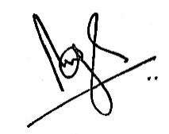

Brij Bhushan Singh
Headmaster
11 May 2019

