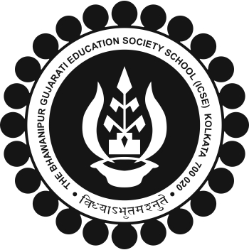
The BGES School (ICSE)
12B Heysham Road
Kolkata 700020

BGES Society Awards classes 8 & 9
The BGES SOCIETY Awards for the Academic Year 2018-19 will be awarded to the following student:

Regn no. | Name | Class | PERCENTAGE | ENGLISH | MATHS | COMP APP
1675 | KARANDEEP SINGH MANJIRA | IX | 80 |  | 86
1683 | JASH AMLANI | IX | 83 |  |  | 95
1900 | DHWANI DOSHI | IX | 85 | 90
2156 | KAJAL BHAVESH DOSHI | VIII | 86 | 87 | 93
2547 | DIPANG RANI SAHOO | VIII | 83 |  |  | 97

ALL STUDENTS TO PLEASE CHECK AND IF ANY DISCREPANCIES THEY BE BROUGHT TO THE NOTICE OF HEADMASTER IMMEDIATELY.
ALL CLASS TEACHER 2018-19 PLEASE CROSS CHECK AND IF ANY DISCREPANCIES THEY BE BROUGHT TO THE NOTICE OF HEADMASTER IMMEDIATELY.
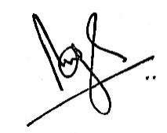

Brij Bhushan Singh
Headmaster
11 May 2019

