Proposed Projects for History and Civics First Term 2020-2021
Last Date of Completion : 15th July 2020
Based on the recent past and as an observer of historical pandemic phase 2020
CLASS 8
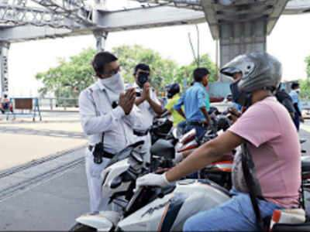
TOPIC : Analysis on the Duties of Citizen of India in the Pandemic /Lockdown Phase.

It must includes
- Detail examination of the period
- Must write in paragraphs
- Use separate parts to understand the whole.
- You can do it in MS Word or MS Power Point or in a form of booklet or in your notebook.
- Use suitable pictures, for Note book or booklets use newspaper cutting to stick pictures.
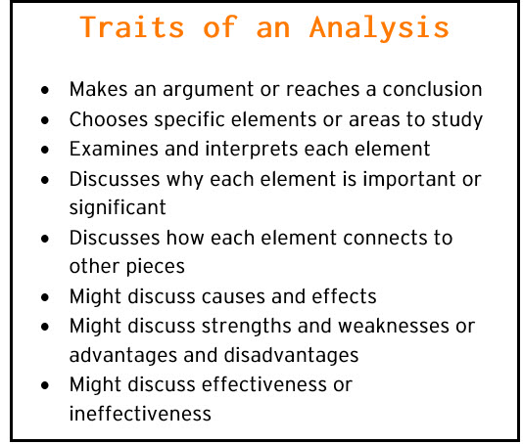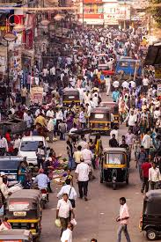
The Project should be mailed tot he respective subject teacher in their mail id given below. In case of done in Notebook or Booklets,please send in pdf format.
Class 8A to sabaridey@ymail.com
Class 8B to baishalid1@gmail.com

