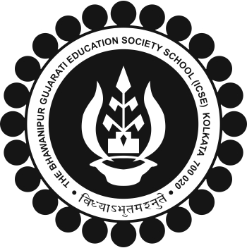
The BGES School (ICSE)
12B Heysham Road
Kolkata 700020

100% ATTENDANCE 2018-2019: CONSECUTIVE FOR 3 OR MORE YEARS SUPERSEDES NOTICE DATED 09 MAY 19

The 100% Attendance Awards for the Academic Year 2018-19 will be awarded to the following student:

 | Class | Reg. No. | Name | CONTINUOUS
 | 3B | 2588 | Aryan Choudhury | 3rd Year
 | 5A | 2333 | Jashdeep Singh | 5th Year
 | 5B | 2232 | Pratham Sheth | 4th Year
 | 8A | 1888 | Aerika B Sheth | 4th Year
 | 9A | 2610 | Krishna Sangani | 4th Year
 |  | 1750 | Amanpreet Singh | 4th Year
 | 9B | 1693 | Snigdha Mondal | 4th Year
 |  | 1792 | Jhalak H Modi | 3rd Year
 | 10A | 1696 | Rashi Rajak | 7th Year
 |  | 1610 | Vishal Choudhury | 8th Year
 | 10B | 2580 | Shristi Jaiswal | 3rd Year

ALL STUDENTS TO PLEASE CHECK AND IF ANY DISCREPANCIES THEY BE BROUGHT TO THE NOTICE OF HEADMASTER IMMEDIATELY.
ALL CLASS TEACHER 2018-19 PLEASE CROSS CHECK AND IF ANY DISCREPANCIES THEY BE BROUGHT TO THE NOTICE OF HEADMASTER IMMEDIATELY.
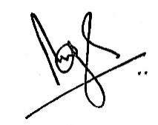
Brij Bhushan Singh
Headmaster
11 May 2019

