PROJECTS/INTERNALS : FOR SESSION 2021-2022
Subject: HCGI
Term: 1st
Last Date to Submit : 15th July 2021

TOPIC : Class 10
ELECTION STRATEGIES OF 2021[WEST BENGAL] a Chronicle: Meetings, Awareness Programmes to digital warfare to get support of Triangular Fights of Election of West Bengal 2021.
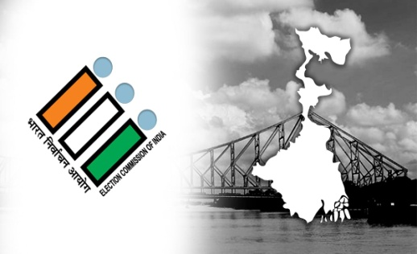
Note- Focus on the new technologies or methods used taglines of different parties, use of social media, the strategies used by Election Commission to held Election in the Pandemic situation and self analytical point of views in the whole procedure. Must put some supporting images. Submit via email duttb5555@gmail.com
In form of: PPT, Word document or Short video.

TOPIC : Class 9
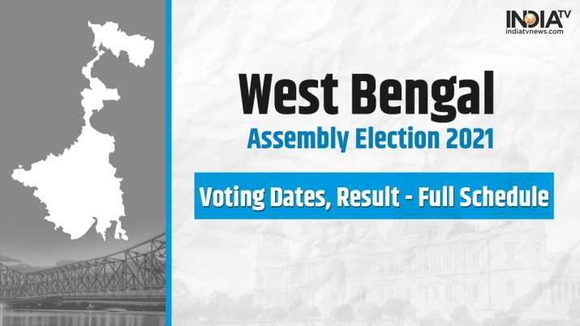
BATTLE TO CREATE STATE GOVERNMENT OF 2021[WEST BENGAL] insight of an onlooker: Different mediums used by political parties to motivate people.
Note- Focus on the general election procedure, about election Commission, who votes, role of media, interesting interview of a voter[from family]. Submit via email duttb5555@gmail.com
In form of: Short video.

TOPIC : Class 8

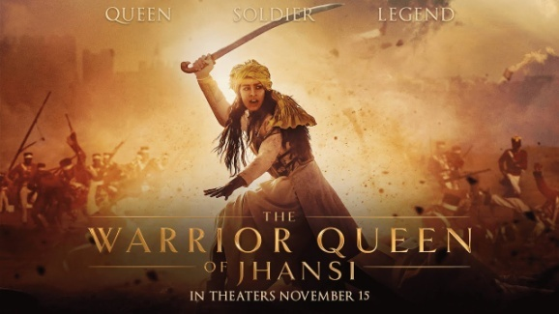
Film Review based on the Topic 1857 The Sepoy Mutiny:
Watch the film ‘The Warrior Queen’, and review it.
Link: https://www.youtube.com/watch?v=Wcnfgx_meKU
Note-
- Watch the film at least once. It's important to watch the whole movie before writing your review, so you have the necessary information to write a thorough, thoughtful piece.
- Express your opinions and support your criticism
- Know the Actors’ portfolios.
- Include a general summary.
- Establish your opinion
- Evaluate the film.
- Conclude
Submit via email duttb5555@gmail.com
In form of: Word Document.

