Proposed Projects for SOCIAL STUDIES ANNUAL EVALUATION 2019-2020
Last Date of Completion : 15th January 2020

Class 5 : Topic- Environment and it’s major concern.
Ban on Plastic-it necessity and how plastics are harmful for the
Environment.
Fold a half of chart Paper[ light coloured] and use both sides of Inside as content writing and suitable picture pasting. Top cover should have the Topic name and supportive decoration only. Cover Page can be done at home.

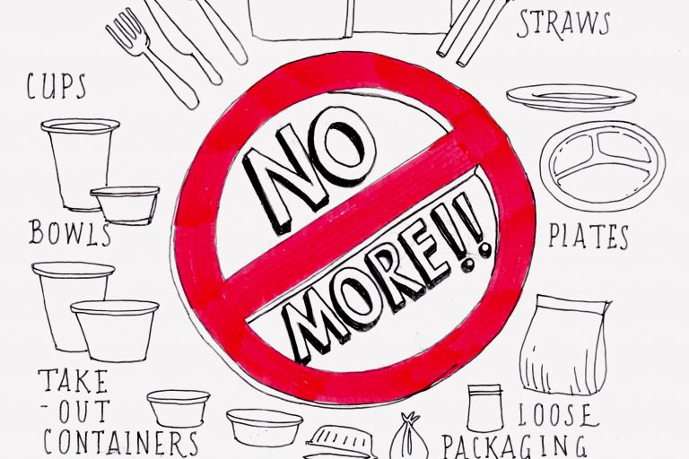

NOTE: Projects will be conducted in the Class Projects and will have 5 Marks Aural.

